# **How to import Collection into Postman?**

***Last Updated On***

[**HOME**](https://qaautomation.expert/)

Postman is a powerful tool that allows developers to test APs efficiently. One of the key features of Postman is the ability to create and share collections, which are groups of API requests that can be organized together. In this tutorial, I will discuss how to import Postman collections.

***Step 1:***Open Postman and navigate to the Collections tab on the left-hand side. Click on the ***“Import”***button located in the top-left corner of the screen.

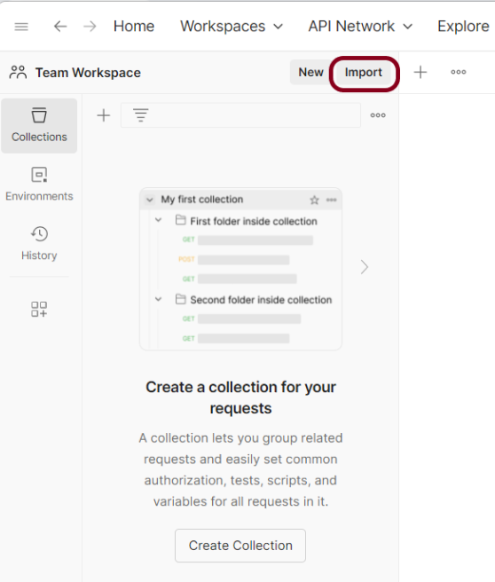

***Step 2:*** In the ***“Import File”*** modal, click on the ***“Choose Files”*** button and select the Postman collection file you wish to import.

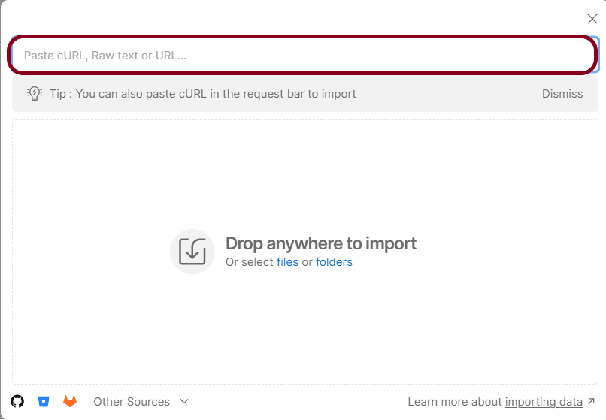

Advertisement

***Step 3:***Once the file has been selected, click on the ***“Import”***button to initiate the import process.

***Step 4:*** After the import process is complete, you should see your newly imported collection listed in the Collections tab.

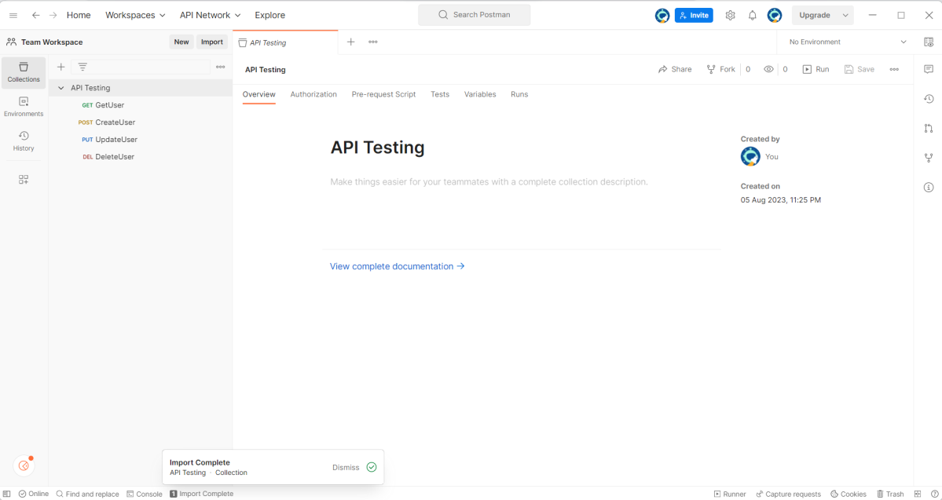

***Step 5:*** Run the tests present in the Collection to see if the import is successful.

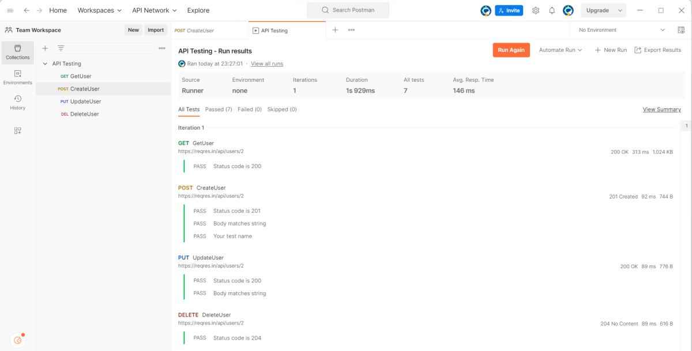

Congratulations on making it through this tutorial and hope you found it useful! Happy Learning!!